**CIS-350  
Infrastructure Technologies**

**Lab 1 Report**

**Student Name**: **Jimi Porter**

1. Insert the *Lab1_Tree* file from p. 25 of the Lab1 instructions into the space provided or use the *Alt-PrtScr* keys to capture the full screen output (full window) from command *TYPE Lab1_Tree* on p. 25 and paste that window here.

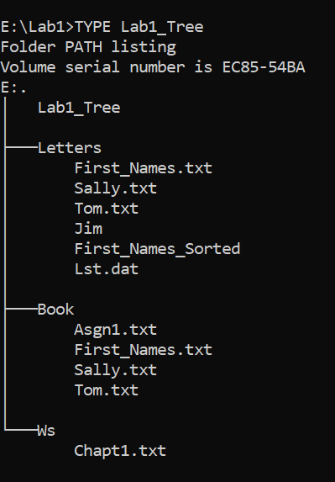

Below you have the following directory structure. At the top there is the root directory denoted by a backslash "\". *CLASSES*, *DOS*, *WINDOWS*, *BOOK*, *FINANCE*, etc. are the names of subdirectories residing under the root directory; *CONFIG.SYS* is the name of a file residing in the root directory, and *chkdsk.exe*, *CHAPTER1.DOC*, *Q.EXE*, etc. are the names of the files stored in the subdirectories. The system prompt displays"*C:****\****>*" which means that the current/default drive is *C* and the current/default directory is the root directory "**\**". The root directory "**\**" is just the origin for other directories/subdirectories.

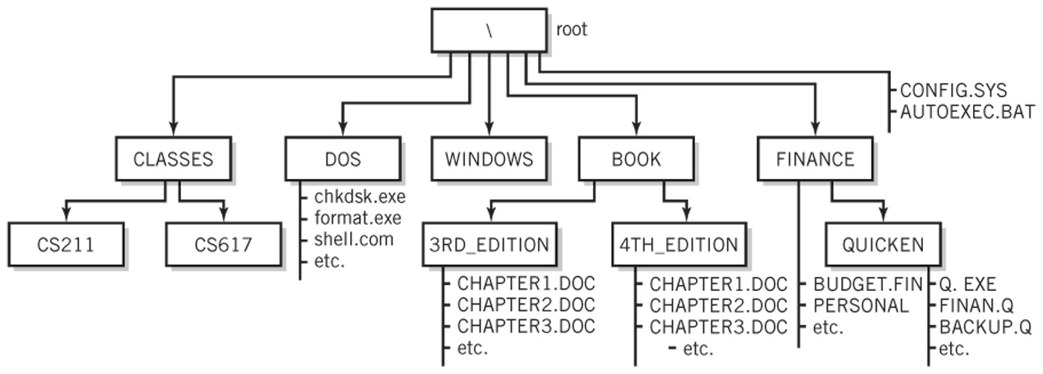

All questions (a) through (j) are based on the above directory diagram. For questions (a) through (f) assume the prompt "*C:* *>*" is displayed.

1. Write a command to copy file *CONFIG.SYS* to directory *DOS*. The copied file should have the same name as the original file, i.e., *CONFIG.SYS*.

**Answer: COPY CONFIG.SYS \DOS**

1. Write a command to copy a file *CONFIG.SYS* to directory *QUICKEN*. The copied file should have new name *CONFIG1.SYS*.

**Answer: COPY CONFIG.SYS \FINANCE\QUICKEN\CONFIG1.SYS**

1. Write a single command to copy all files whose names start with letter *C* from directory *4TH_EDITION* to directory *FINANCE*.

**Answer: COPY \BOOK\4TH EDITION\C* \FINANCE**

1. Write a single command to erase from directory *4TH_EDITION* all files whose names start with letter *C*.

**Answer: ERASE \BOOK\4TH EDITION\C\***

1. How many files would be erased by the command from p. (d) above? **Answer: 3 Files**
2. Assume that *AUTOEXEC.BAT* is a large file. What command would you use to display the contents of the file one screen at a time (to prevent the output from scrolling off the screen)? **Answer: TYPE AUTOEXEC.BAT MORE**
3. Look at the diagram. Assume that prompt "*C:\FINANCE\QUICKEN>*" is displayed, meaning that the current/default drive is *C* and the current/default directory is *\FINANCE\QUICKEN*. Write two separate *SORT* commands. Each of the two commands would accept input from file *BACKUP.Q*. However, the first command would route the output to file *BACKUP1.Q*, and the second one would append the output to file *BACKUP2.Q*.

**Answer: SORT < BACKUP.Q > BACKUP1.Q**

**SORT < BACKUP.Q >> BACKUP2.Q**

1. Look at the diagram. Assume that prompt "*C:\FINANCE\QUICKEN>*" is displayed. Write the command which would change the current directory to *FINANCE*.

**Answer: CD..**

1. Look at the diagram. Assume that prompt "*C:\FINANCE>*" is displayed. In the space provided, sketch the directory structure with the subdirectory and file names which would command *TREE* /F generate.

**Answer:**

**FINANCE_Tree**

**---------BUDGET.FIN**

**---------PERSONAL**

**---------QUICKEN**

**Q.EXE**

**FINAN.Q**

**BACKUP.Q**

1. Now assume that the "C:\ " prompt is displayed. Describe what a command

*DIR | SORT > DirList* would do.

**Answer: This command would sort the items within the directory and then save the output to a file called DirList. The output will not be displayed on the command prompt.**

1. Optional. Briefly describe any issues with the commands which did not work. Point me to the specific pages and suggest changes. Thanks.

**This was fun, I like typing in the command prompt.**